**1.1 Push-button switch**

This is the circuit I used to create a pull-up resistor:

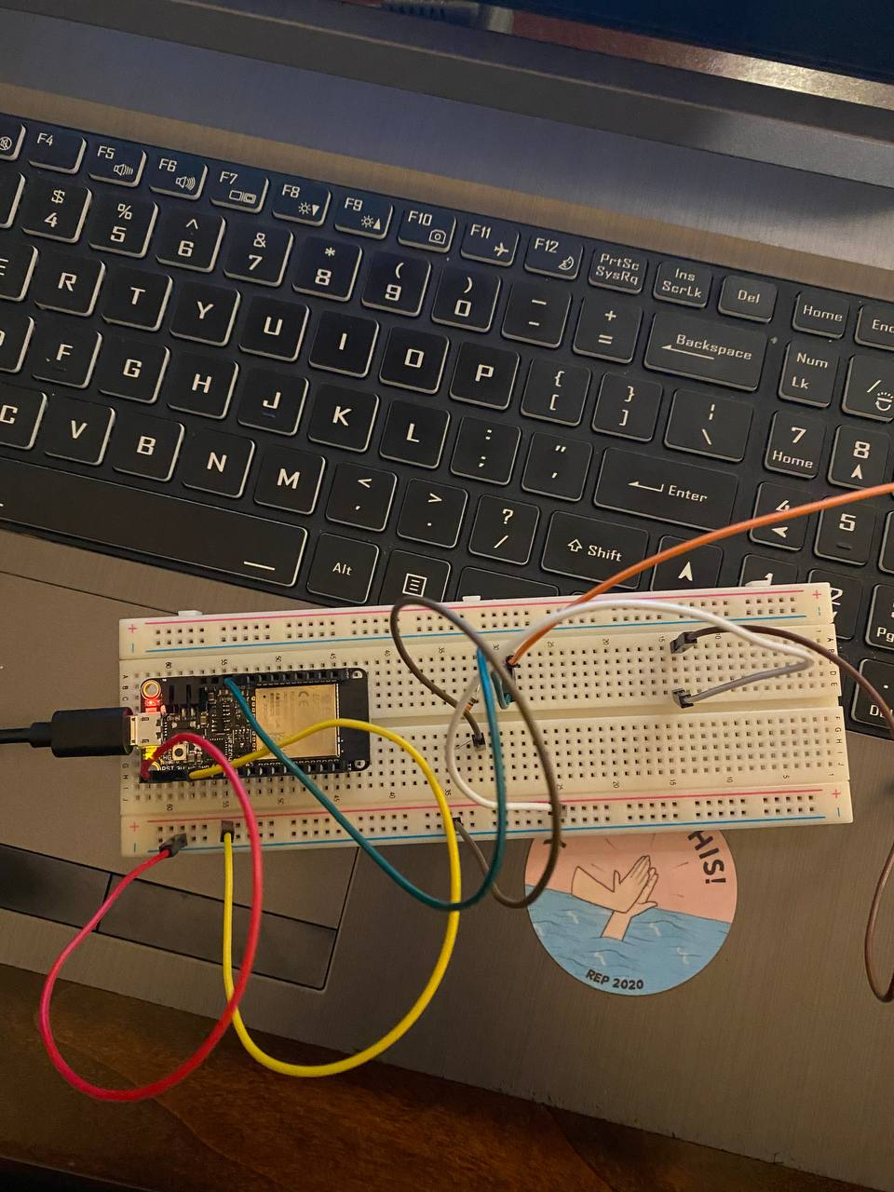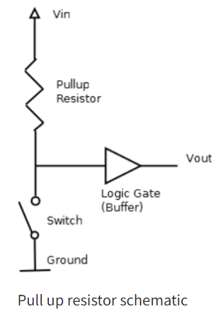

In the pull-down resistor circuit, the live was connected to the button (switch), then the logic gate, then the resistor and the ground.

I changed the connections to fit the pull-up resistor circuit. For this circuit, my live will go to the resistor, then to the logic gate, then the button, and finally ground. Originally, I was also using pin 12 for my input pin by following the diagram but got an error (timed out waiting for packet content) when implementing pull-up. This is because this pin is a bootstrapping pin and should be low to enter UART, hence I changed to pin 13 for this pull-up circuit.

**1.3 Debouncing the push button switch**

I made use of the millis() function to debounce my switch. I initialized variables for my current and previous button states. If the current state is not the same as my previous, I start the millis() timer. I created a variable for my debounce delay, which I set at 500ms. After completing the duration of this debounce delay time, I check the current button state. If it is high, I call the given function to print out the string “Pressed!”. At the end of the loop, I will set this current state to the previous state for the next loop.